A.S.PACK 05

SRI LANKA
8 DAYS TOUR
CODE: A.S.PACK 05

Leisure Travel Sri Lanka
Shop 1, High Street, Epping Vic 3076
Telephone: 0416 714 949
Fax: (03) 9408 0133
E-mail: info@leisuretravelsrilanka.com
Web Site: http://www.leisuretravelsrilanka.com

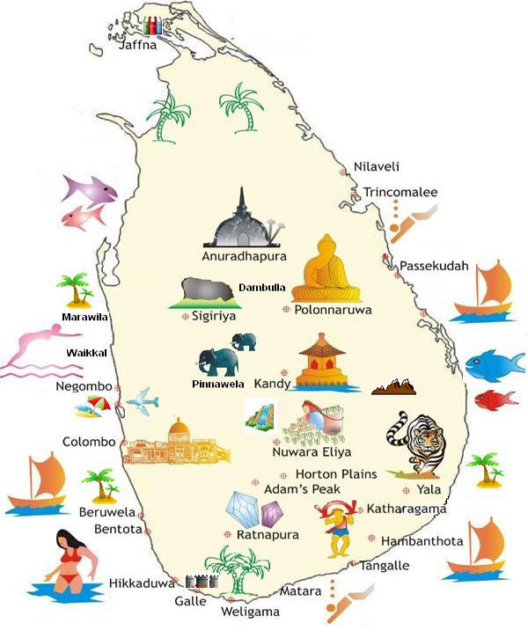
PROGRAMME: COLOMBO /WILDLIFE/HILL COUNTRY/ANCIENT CITIES
DURATION: 07 NIGHTS / 08 DAYS TOUR
PERIOD: 01/11/14– 30/04/15

Tour Itinerary

DAY 01 Arrival and transfer to Hotel
Do a city tour of Colombo. Colombo like many capital cities in developing countries is fast changing its face. Almost overnight, skyscrapers arise from where old buildings once stood. Yet in some parts, the Old World charm is retained. As an example there is a 100 year old clock tower and several British built colonial buildings. Other places of interest are the Pettah bazaar where one can shop for bargains, the old Parliament in Fort, a Hindu and a Buddhist temple, residential areas where you find the stately homes of the affluent and the Bandaranaike Memorial International Conference Hall - BMICH, an outright gift to Sri Lanka from the People's Republic of China.Overnight stay at Cinnamon Grand Colombo ( Deluxe) / Grand Oriental Hotel (Standard ).

DAY 02 After Breakfast proceed to Yala. En-route visit Galle.
Do a city tour of Galle, which was once the chief port of Ceylon as Sri Lanka was named by the British, and which is a world heritage site now. It is still well known for hand-made lace. You can also visit the Galle Fort, spanning 90 acres which was originally built by the Portuguese and later extended by the Dutch in 1663. There is also a very interesting Dutch Museum. Overnight stay at Chaaya Wild (Deluxe) / Elephant Reach (Standard )

DAY 03 After Breakfast proceed to Nuwara Eliya
Do a safari of the Yala National Park by jeep. Yala is the largest National Park in Sri Lanka and is home for wild elephants, wild boar, wild buffaloe, leopard, bear, deer and crocodile. You could also see large flocks of migratory and indigenous birds.
Overnight stay at Hotel Tea Factory (Deluxe ) / Galway Forest Lodge (Standard)
DAY 04 After Breakfast proceed to Kandy
Visit a tea plantation and a tea factory, where the best tea in the world is produced. You will be told all about the process of manufacturing tea. You can also see how tea is graded. Taste a cup of pure Ceylon tea in the factory.
Visit the Peradeniya Botanical Gardens. This botanical garden was first built as a pleasure garden by a Sinhala king and was expanded by the British. It is 147 acres in extent and provides an amazing variety of trees, plants and flowers.
Do a city tour of Kandy. Kandy was the last capital of the Sri Lankan kings, and is a World Heritage Site. The name Kandy conjures visions of splendour and magnificence. Many of the legends, traditions and folklore are still lovingly kept alive. Drive around the Kandy Lake built by the last Sinhala king Sri Wickrama Rajasinghe in 1798. Visit the Kandy town and Bazaar, the arts & crafts centre and a gem museum and a lapidary. In the evening visit the Temple of the Tooth Relic and thereafter witness a cultural show featuring traditional Sri Lankan dancing.Overnight stay at Earls Regency Hotel (Deluxe ) / Hill Top (Standard )
DAY 05 After Breakfast proceed to Kandalama
Visit a spice garden in Matale to see the different spices, which Sri Lanka is famous for. You will be introduced to different spices and shown how some of these spices are grown and processed. Climb the 5th century Sigiriya rock fortress which is a world heritage site, built by King Kashyapa (477-495 AD). The 'Lion Rock' is a citadel of unusual beauty rising 200 metres from the scrub jungle. The rock was the innermost stronghold of the 70 hectare fortified town. A moat, rampart, and extensive gardens including the renowned water gardens ring the base of the rock. Visit the world-renowned frescoes of the 'Heavenly Maidens' of Sigiriya, which are in a sheltered pocket of the rock approached by a spiral stairway. These Frescoes are painted in earth pigments on plaster. Overnight stay at Heritance Kandalama (Deluxe ) / Hotel Kassapa Lion Rock (Standard)
DAY 06 After Breakfast visit Polonnaruwa, which was the 2nd capital city of Sri Lanka, built in the 11th and 12th centuries AD, and which is a world heritage site. Here you can see the ruins of the Royal Palace, the Gal Viharaya -where 4 splendid statues of the Buddha in 'Upright', 'Sedentary' and 'Recumbent' postures carved out of rock, the Audience Hall, the Lotus Bath, king Parakramabahu's statue, and the Parakrama Samudraya lake built by King Parakramabahu the great. There are also monuments of famous places of worship such as the Shiva Temple, the Lankathilake, the Watadage, the Galpotha, the Kiri Vehera and the remains of a former Temple of the Tooth Relic.Overnight stay at Heritance Kandalama (Deluxe ) / Hotel Kassapa Lion Rock (Standard)
DAY 07 After Breakfast proceed to Colombo
Visit the elephant orphanage in Pinnawala. This orphanage is the home for about 60 elephants, out of which some are baby elephants found abandoned or orphaned in the wild. They are being cared, fed and trained by the wild life authorities. The best time to visit is during the feeding times, when one will have the opportunity of seeing the baby elephants being bottle-fed. Also could accompany the elephants to a river close-by and see them having their daily bath.Overnight Stay Cinnamon Grand Colombo ( Deluxe) / Grand Oriental Hotel (Standard).
DAY 08 After Breakfast proceed to airport for departure
Cost for Deluxe (5 Star) package
Price per person sharing double/ triple room for a Group of:

Rates valid from: 01/11/14 to 20/12/14

 | 2 PAX | 3 – 4 PAX | 5 – 6 PAX
Amount | 1260 | 1188 | 1100
Single Supplement | 480 | 480 | 480

Rates valid from 21/12/14 to 15/01/15

 | 2 PAX | 3 – 4 PAX | 5 – 6 PAX
Amount | 1397 | 1320 | 1237
Single Supplement | 575 | 575 | 575

Rates valid from 16/01/15 to 30/04/15

 | 2 PAX | 3 – 4 PAX | 5 – 6 PAX
Amount | 1248 | 1215 | 1127
Single Supplement | 500 | 500 | 500

CHIRSTMAS & NEW YEAR SUPPLEMNTS

CINNAMON WILD (5 Star)  Compulsory x’mas supplement  Compulsory New Year eve supplement  HERITANCE KANDALAMA (5 Star)  Compulsory x’mas supplement  Compulsory New Year eve supplement  EARLS REGENCY HOTEL (5 Star)  Compulsory Christmas Eve supplement  Compulsory New Year Eve supplement  TEA FACTORY (4.5 Star)  Compulsory Christmas Eve supplement  Compulsory New Year’s Eve supplement | US $ 110.00 per adult  US $ 120.00 per adult  US $ 150.00 per adult  US $ 175.00 per adult  US$ 150/- per person  US$ 150/- per person  US$ 150/- per person  US$ 150/- per person
Quotation for Standard (3 Star) package
Price per person sharing double/ triple room for a Group of:

Rates valid from 01/11/14 to 20/12/14

 | 2 PAX | 3 – 4 PAX | 5 – 6 PAX
Amount | 930 | 848 | 754
Single Supplement | 195 | 195 | 195

Rates valid from 21/12/14 to 15/01/15

 | 2 PAX | 3 – 4 PAX | 5 – 6 PAX
Amount | 946 | 870 | 775
Single Supplement | 215 | 215 | 215

Rates valid from 16/01/15 to 30/04/15

 | 2 PAX | 3 – 4 PAX | 5 – 6 PAX
Amount | 924 | 853 | 760
Single Supplement | 200 | 200 | 200

CHIRSTMAS & NEW YEAR SUPPLEMNTS

ELEPHANT REACH (3 Star)
Compulsory Christmas Eve supplement -US$ 40/- per person
Compulsory New Year Eve supplement -US$ 50/- per person

KASSASPA LIONS ROCK (3 Star)
Compulsory Christmas Eve supplement -US$ 30/- per person
Compulsory New Year Eve supplement -US$ 35/- per person

HILLTOP HOTEL (3 Star)
Compulsory Christmas Eve supplement -US$ 62/- per person
Compulsory New Year Eve supplement -US$ 62/- per person

GALWAY FOREST LODGE (3 Star)
Compulsory Christmas Eve supplement -US$ 25/- per person
Compulsory New Year Eve supplement -US$ 30/- per person
Discount for children (below 12 years) sharing parents room: 30% on the per person sharing double room rate.
Discount for the 3rd person sharing triple room: 10% on the per person sharing double room rate.
Triple Room – Please note that the extra bed is a foldable rolling bed,

The above prices include:
- Accommodation (in standard rooms) on Bed and breakfast basis for 7 nights from breakfast on day 2 to breakfast on day 8 at hotels specified or at hotels of similar standard.
- Transportation by air-conditioned vehicle as per the itinerary
- Entrance fees for Yala National Park, Kandy Temple, Botanical Gardens, Cultural Show, Sigiriya, Polonnaruwa, Elephant Orphanage, Tips And Porterage at Hotels
- Cost of Jeep Yala
- Services of an English Speaking Driver Guide.

The prices do not include:

- Video Camera permits at Pinnawala Elephant Orphanage.
- Compulsory x’mas and New Year supplement.
- Video Camera and Still Camera permits at the Temple of the Tooth Relic in Kandy.
- Entrance fees to sites not specified above.
- Lunch & dinner throughout the tour.
- Cost of beverage throughout the tour.
- Expenses of a personal nature.
- Tips and Porterage
- Any other services not specified above.

Conditions that apply for all the above packagers

Other conditions:
- Optional excursions and additional services could be provided for which we will charge additionally.
- Visits to wild life parks will be at client's own risk.
- Jeeps available are very basic with basic insurance cover (not comprehensive as in the case of vehicles used for tours).

Cancellation Charges:

5 days or less | 100% cancellation charge
6 days and 14 days | 50% or the equivalent of the first 2 days charges depending on t he program and period of stay
Above 15 days | No cancellation provided. No commitment or advances are made to third parties

Hotel rules and regulations:

The official check-in time at all hotels will be 1200hrs.
The official checkout time at all hotels will be 1100hrs.
Cancellation policy will be applicable for any reduction of rooms after the release period.
Or more – no cancellation charges provided no commitment or advances are made to 3rd parties.

Travel Insurance:

Bookings will not be accepted without travel insurance. Customers must provide proof of travel insurance when making a confirmed booking. Organizing travel insurance is an essential part of preparing for your overseas trip. Travel insurance will help you cope with the unexpected health issue problems while on holiday. It is usually the last thing that comes to one’s mind so please don’t travel without insurance.
The commonwealth bank offers complementary travel insurance.

Check this link for more information:

https://www.commbank.com.au/personal/credit-cards/complimentary-insurance-cover.html

We wish you a memorable holiday.

Leisure Travel Sri Lanka
Shop 1, High Street, Epping Vic 3076
Telephone: 0416 714 949
Fax: (03) 9408 0133
E-mail: info@leisuretravelsrilanka.com
Web Site: http://www.leisuretravelsrilanka.com

